VPN-against-Firewall Lab: Bypassing Firewalls using VPN

NAME: JASHWANTH REDDY GANGULA

SUID: 646254141

**1.Overview:**

The objective of this lab is to do understand how we use VPN to bypass egress firewalls. VPN technology depends on IP tunneling and encryption. We will limit ourselves to only IP tunneling and the traffic inside our tunnel won’t be encrypted.

**2.Lab Environment**

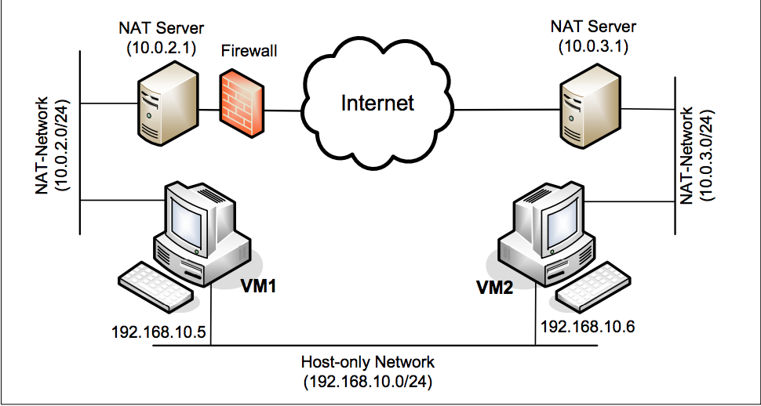

We have created 2 VM, let’s call them VM1 and VM2. VM1 is connected to NAT-adapter network with CIDR 10.0.2.0/24. To create a new NAT adapter, go to Virtual Machine->Preferences->Network->Add new Nat adapter as below.

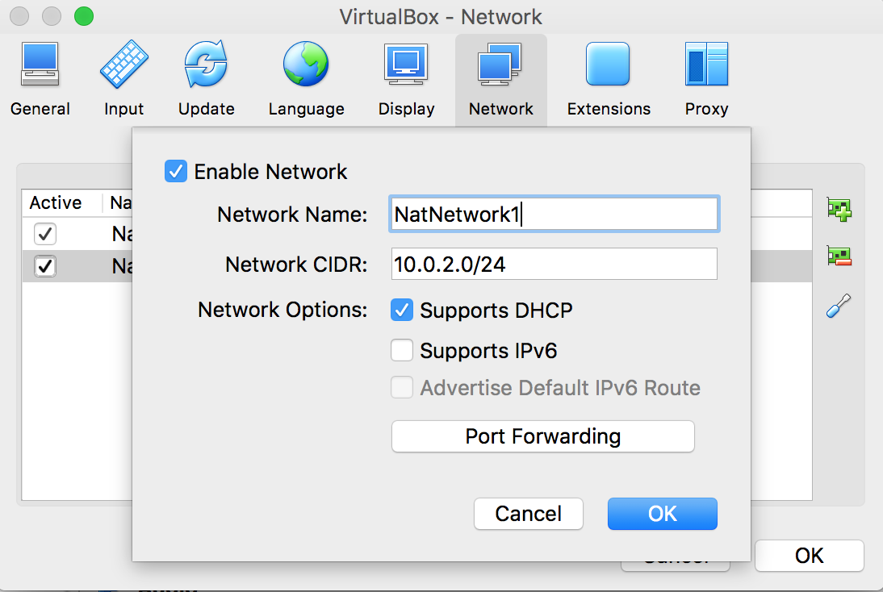

Similarly, we connect or VM2 to NAT adapter with CIDR(classless-inter-domain-routing) of

10.0.3.0/24. Now the creation of NAT adapter for a VM allows it to reach the internet, and also

communicate within its own NAT network. But communication with the host is not possible. For

this we attach each VM to a second adapter i.e., host-only adapter as below.

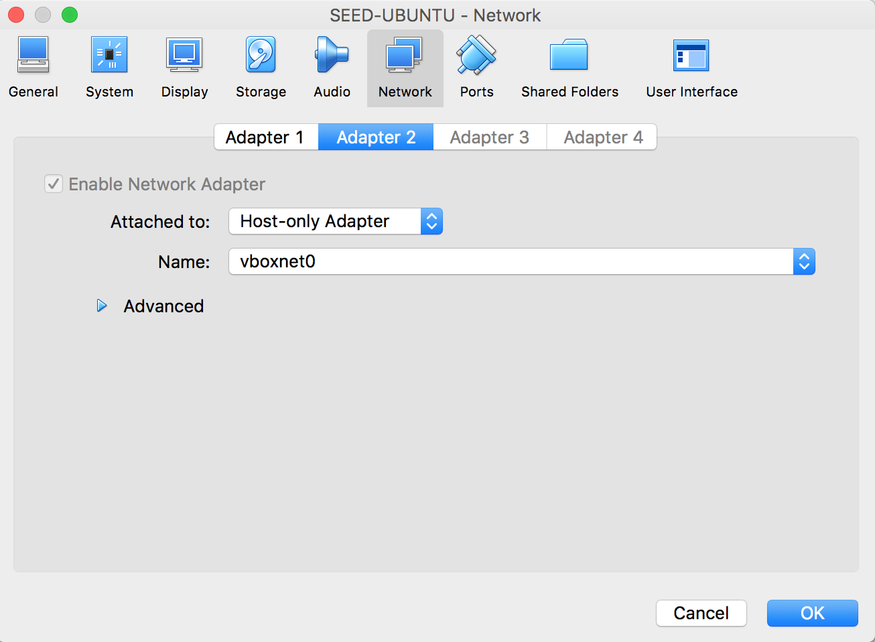

(Reference <http://www.cis.syr.edu/~wedu/seed/Documentation/VirtualBox/VirtualBox_MultipleVMs.pdf> )

Namely, each VM should have two network adapters, one configured to “NAT” and the other configured to “Host-only”. Each VM will basically connect to two virtual networks, one through the “NAT” adapter, and the other through the “Host-only” adapter. Therefore, each VM has two IP addresses. If you want to reach another VM, you need to use that VM’s IP address that is associated with the “Host-only” adapter. Here VM1 has two interfaces – enp0s3 with IP 10.0.2.6 (NAT adapter1) and enp0s8 with IP 192.168.56.102(host-only)

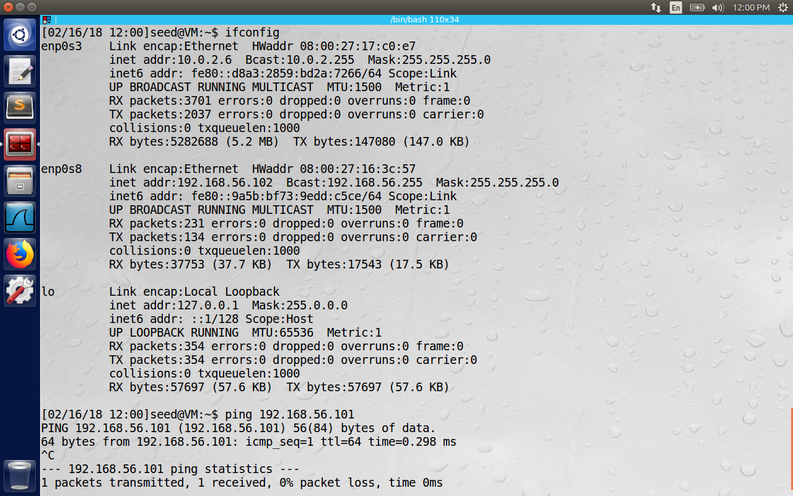

**3.Lab Tasks**

3.1 Task 1: Create a Host-to-Host Tunnel using TUN/TAP

TUN and TAP are virtual network kernel drivers; they implement network device that are supported entirely in software. TAP simulates an Ethernet device and it operates at Layer-2 packets such as Ethernet frames. TUN simulates network layer device and it operates with layer-3 packets such as IP packets. With TUN/TAP we can create a virtual network interfaces.

A user space program can attach itself to TUN/TAP interface. When packets are sent by OS to TUN/TAP interface (instead of going out through wire, because it is not physical) it reaches the user space programs. Similarly, when the user space programs send IP packets to the TUN/TAP interface it reaches the kernel, which decides the routing path of the packet. i.e., for kernel it appears as if the packets are coming from an external interface.

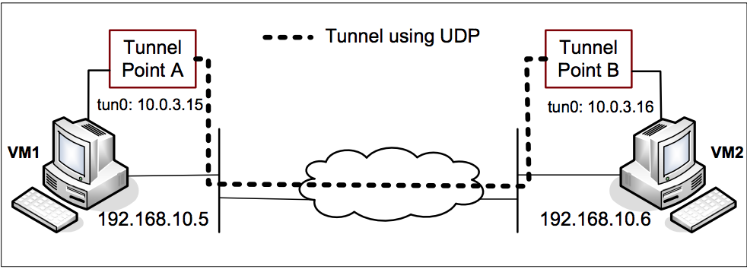

Here We have 2 programs tunserver.c tunclinet.c

VM2 Setup:

Here we assume that VM2 is the server side of the setup. The code is as follows:

#include <fcntl.h>

#include <stdio.h>

#include <unistd.h>

#include <string.h>

#include <arpa/inet.h>

#include <linux/if.h>

#include <linux/if_tun.h>

#include <sys/ioctl.h>

#define PORT_NUMBER 55555

#define BUFF_SIZE 2000

struct sockaddr_in peerAddr;

int createTunDevice(char* dev) {

int tunfd, err;

struct ifreq ifr;

memset(&ifr, 0, sizeof(ifr));

ifr.ifr_flags = IFF_TUN | IFF_NO_PI;

if ((tunfd = open("/dev/net/tun", O_RDWR)) < 0 ) {

perror("Opening /dev/net/tun");

return tunfd;

}

if ((err = ioctl(tunfd, TUNSETIFF, (void *)&ifr)) < 0 ) {

perror("ioctl(TUNSETIFF)");

close(tunfd);

return err;

}

// tunfd = open("/dev/net/tun", O_RDWR);

// ioctl(tunfd, TUNSETIFF, &ifr);

strcpy(dev, ifr.ifr_name);

return tunfd;

}

int initUDPServer() {

int sockfd;

struct sockaddr_in server;

char buff[100];

memset(&server, 0, sizeof(server));

server.sin_family = AF_INET;

server.sin_addr.s_addr = htonl(INADDR_ANY);

server.sin_port = htons(PORT_NUMBER);

sockfd = socket(AF_INET, SOCK_DGRAM, 0);

bind(sockfd, (struct sockaddr*) &server, sizeof(server));

// Wait for the VPN client to "connect".

bzero(buff, 100);

int peerAddrLen = sizeof(struct sockaddr_in);

int len = recvfrom(sockfd, buff, 100, 0,

(struct sockaddr *) &peerAddr, &peerAddrLen);

printf("Connected with the client: %s\n", buff);

return sockfd;

}

void tunSelected(int tunfd, int sockfd){

int len;

char buff[BUFF_SIZE];

printf("Got a packet from TUN\n");

bzero(buff, BUFF_SIZE);

len = read(tunfd, buff, BUFF_SIZE);

sendto(sockfd, buff, len, 0, (struct sockaddr *) &peerAddr,

sizeof(peerAddr));

}

void socketSelected (int tunfd, int sockfd){

int len;

char buff[BUFF_SIZE];

printf("Got a packet from the tunnel\n");

bzero(buff, BUFF_SIZE);

len = recvfrom(sockfd, buff, BUFF_SIZE, 0, NULL, NULL);

write(tunfd, buff, len);

}

int main (int argc, char * argv[]) {

int tunfd, sockfd;

char if_name[IFNAMSIZ] = "";

tunfd = createTunDevice((char *)&if_name);

printf("Successfully connected to interface %s\n", if_name);

sockfd = initUDPServer();

// Enter the main loop

while (1) {

fd_set readFDSet;

FD_ZERO(&readFDSet);

FD_SET(sockfd, &readFDSet);

FD_SET(tunfd, &readFDSet);

select(FD_SETSIZE, &readFDSet, NULL, NULL, NULL);

if (FD_ISSET(tunfd, &readFDSet)) tunSelected(tunfd, sockfd);

if (FD_ISSET(sockfd, &readFDSet)) socketSelected(tunfd, sockfd);

}

}

Let’s try to understand the code.

The method createTunDevice () creates a file descriptor that can be used by user space programs to attach and read/write to the virtual TUN network device.

The method initUDPServer () creates a listener on port 55555 for accepting new UDP connections.

The method tunSelected () reads an entire packet from the tunnel interface and sends it through the socket to the UDP channel established.

The method socketSelected() reads a packet from the channel and sends it to the TUN interface.

The main() method uses select() so that it listens on both the channel and TUN interface for packets, and corresponding methods to handle the packets are called.

Now run tunserver.c program to create TUN interface and bring it up.

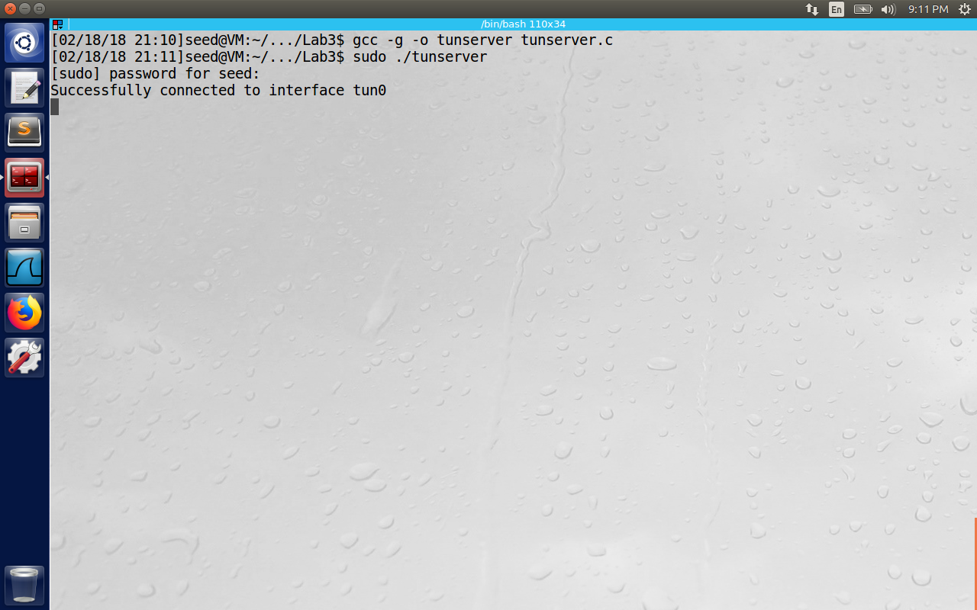

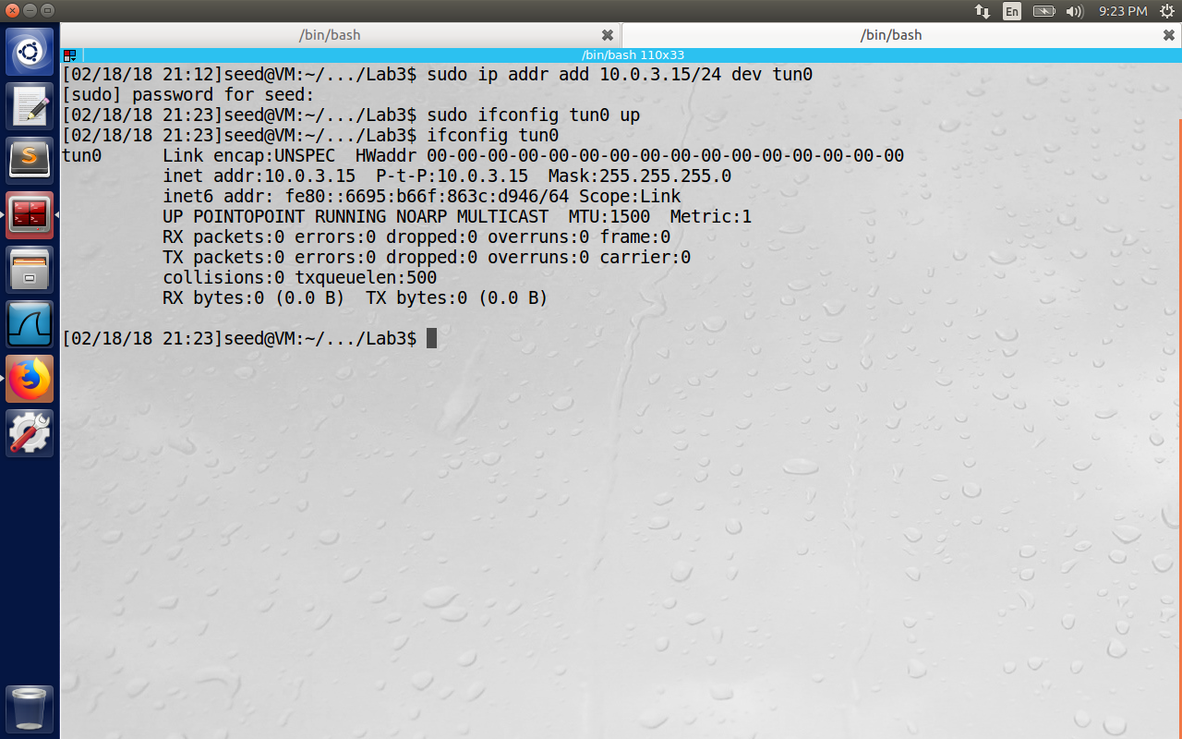

VM1 Setup:

Here we assume that VM1 is the client side of the setup.

#include <fcntl.h>

#include <stdio.h>

#include <unistd.h>

#include <string.h>

#include <stdlib.h>

#include <arpa/inet.h>

#include <linux/if.h>

#include <linux/if_tun.h>

#include <sys/ioctl.h>

#define BUFF_SIZE 2000

#define PORT_NUMBER 55555

#define SERVER_IP "192.168.56.101"

struct sockaddr_in peerAddr;

int createTunDevice(char *dev) {

int tunfd, err;

struct ifreq ifr;

memset(&ifr, 0, sizeof(ifr));

ifr.ifr_flags = IFF_TUN | IFF_NO_PI;

// tunfd = open("/dev/net/tun", O_RDWR);

if ((tunfd = open("/dev/net/tun", O_RDWR)) < 0 ) {

perror("Opening /dev/net/tun");

return tunfd;

}

if ((err = ioctl(tunfd, TUNSETIFF, (void *)&ifr)) < 0 ) {

perror("ioctl(TUNSETIFF)");

close(tunfd);

return err;

}

// ioctl(tunfd, TUNSETIFF, &ifr);

strcpy(dev, ifr.ifr_name);

return tunfd;

}

int connectToUDPServer(){

int sockfd;

char *hello="Hello";

memset(&peerAddr, 0, sizeof(peerAddr));

peerAddr.sin_family = AF_INET;

peerAddr.sin_port = htons(PORT_NUMBER);

peerAddr.sin_addr.s_addr = inet_addr(SERVER_IP);

sockfd = socket(AF_INET, SOCK_DGRAM, 0);

// Send a hello message to "connect" with the VPN server

if (sendto(sockfd, hello, strlen(hello), 0,

(struct sockaddr *)&peerAddr, sizeof(peerAddr)) < 0) {

perror("sendto()");

exit(1);

}

return sockfd;

}

void tunSelected(int tunfd, int sockfd){

int len;

char buff[BUFF_SIZE];

printf("Got a packet from TUN\n");

bzero(buff, BUFF_SIZE);

len = read(tunfd, buff, BUFF_SIZE);

sendto(sockfd, buff, len, 0, (struct sockaddr *) &peerAddr,

sizeof(peerAddr));

}

void socketSelected (int tunfd, int sockfd){

int len;

char buff[BUFF_SIZE];

printf("Got a packet from the tunnel\n");

bzero(buff, BUFF_SIZE);

len = recvfrom(sockfd, buff, BUFF_SIZE, 0, NULL, NULL);

write(tunfd, buff, len);

}

int main (int argc, char * argv[]) {

int tunfd, sockfd;

char if_name[IFNAMSIZ] = "";

tunfd = createTunDevice((char *)&if_name);

printf("Successfully connected to the interface %s\n", if_name);

sockfd = connectToUDPServer();

// Enter the main loop

while (1) {

fd_set readFDSet;

FD_ZERO(&readFDSet);

FD_SET(sockfd, &readFDSet);

FD_SET(tunfd, &readFDSet);

select(FD_SETSIZE, &readFDSet, NULL, NULL, NULL);

if (FD_ISSET(tunfd, &readFDSet)) tunSelected(tunfd, sockfd);

if (FD_ISSET(sockfd, &readFDSet)) socketSelected(tunfd, sockfd);

}

}

This is the tunclient.c program which is similar to the server program except that this needs to connect to the UDP server.

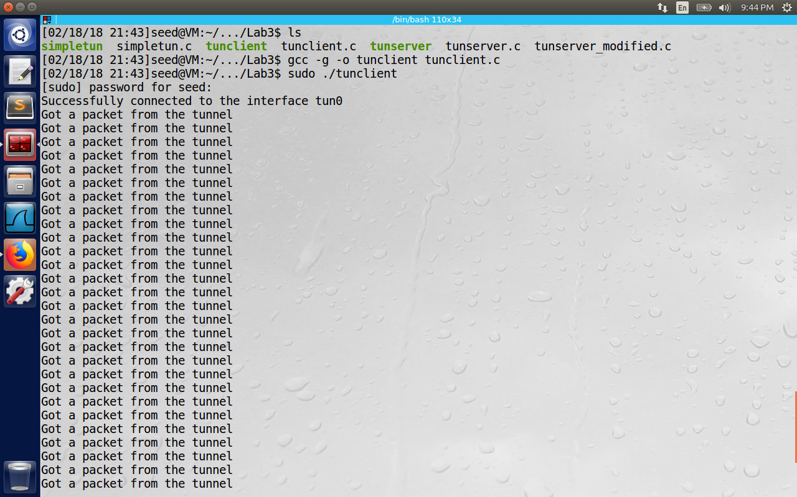

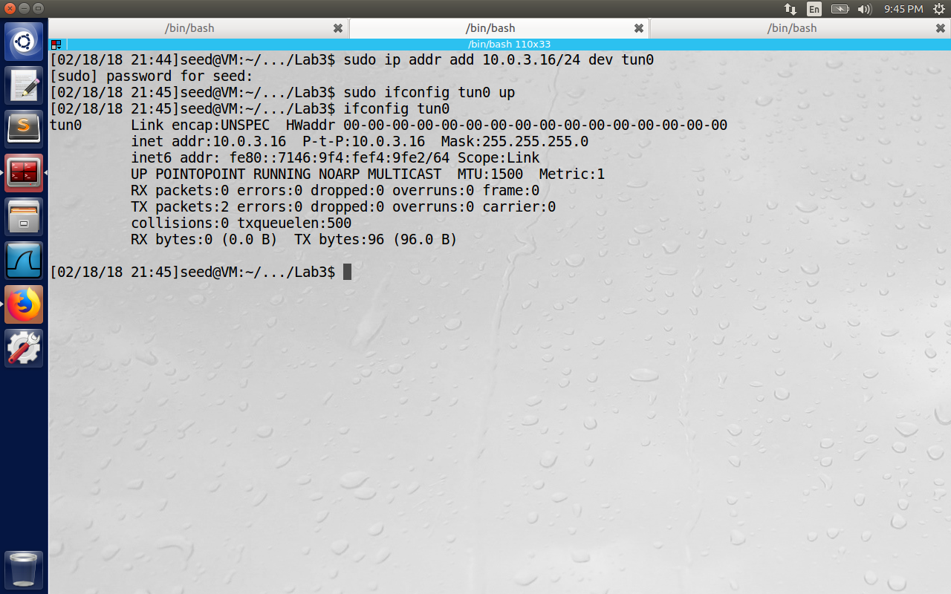

Now we see the channel established between server and client.

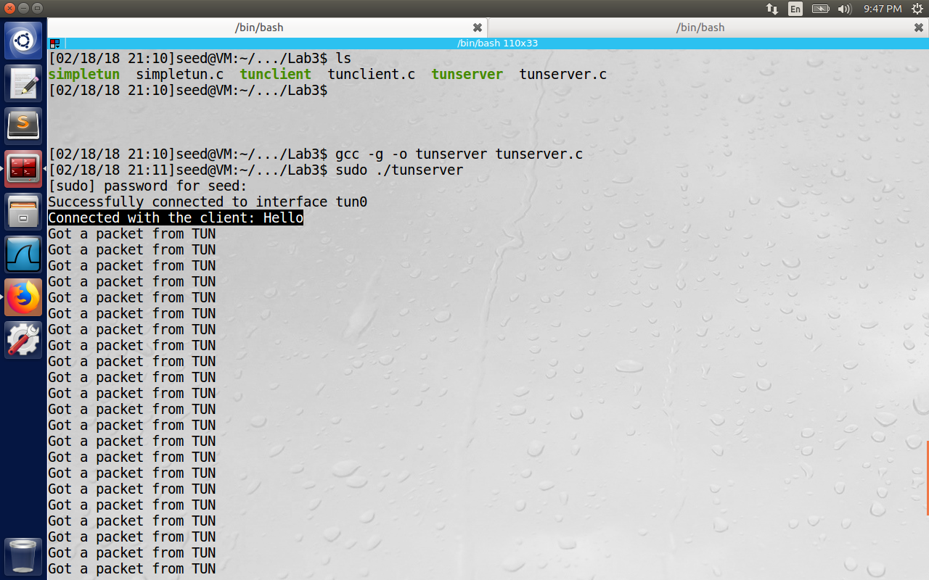

We see the message at the server end connected with the client.

4. Routing Path: After the above two steps, the tunnel will be established. Before we can use the tunnel, we need to set up the routing path on both machines to direct the intended outgoing traffic through the tunnel. The following routing table entry directs all the packets for the 10.0.3.0/24 network through the interface tun0, from where the packet will be hauled through the tunnel.

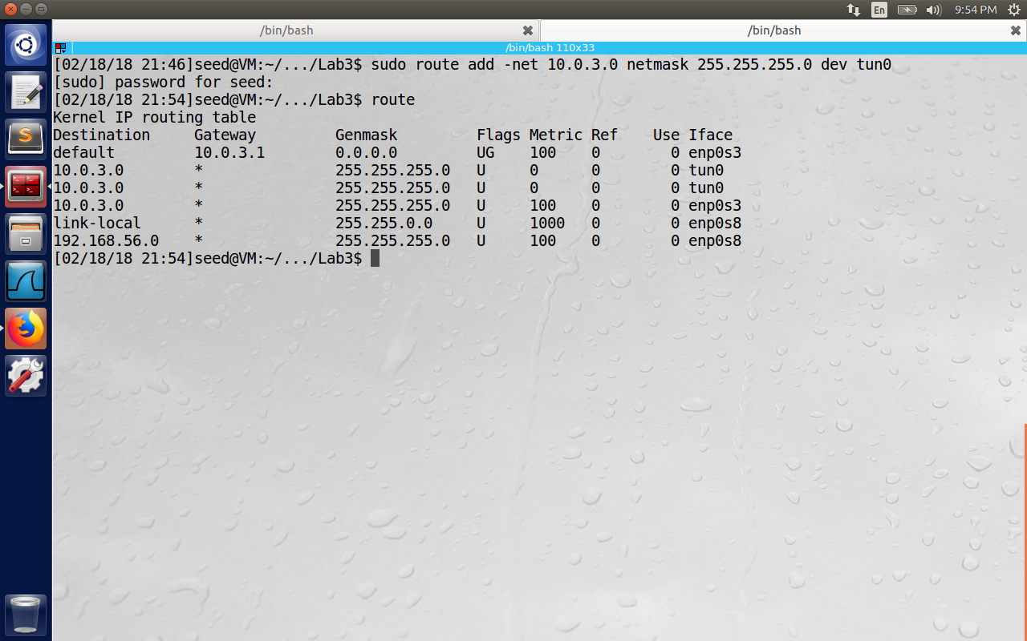

**Using Tunnel:**

Ping 10.0.3.16

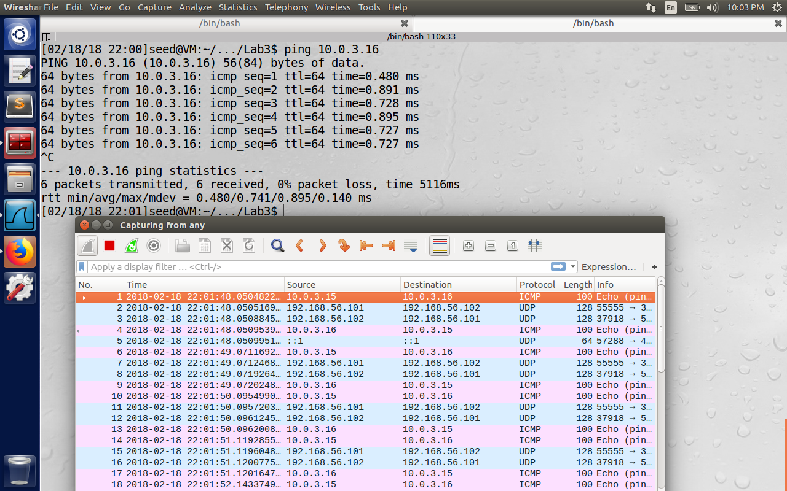

ssh 10.0.3.16

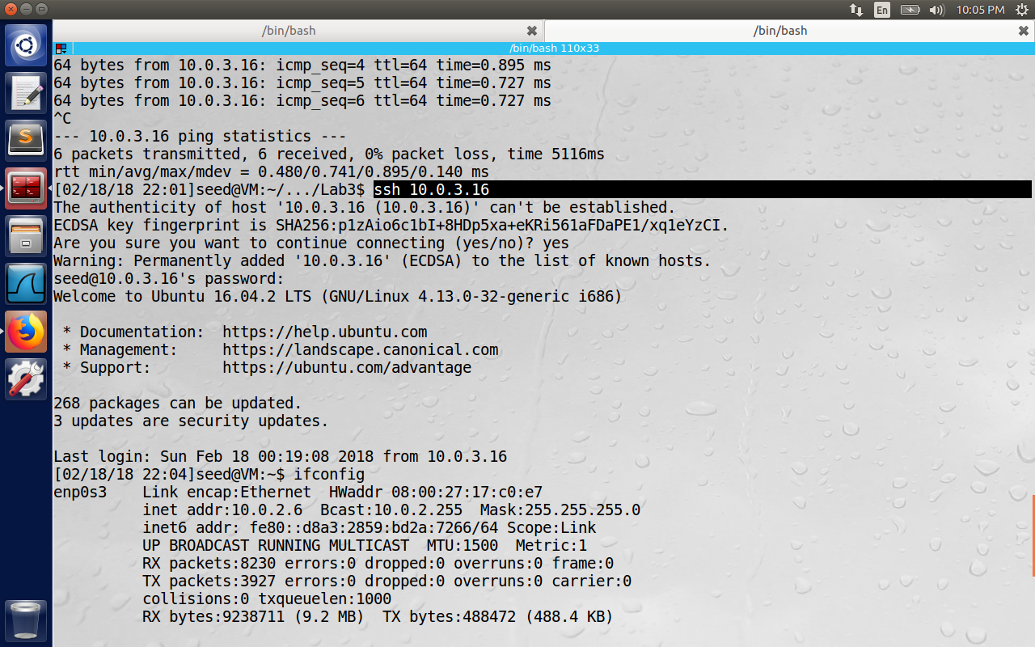

From client to server:

Ping 10.0.3.15

Ssh 10.0.3.15

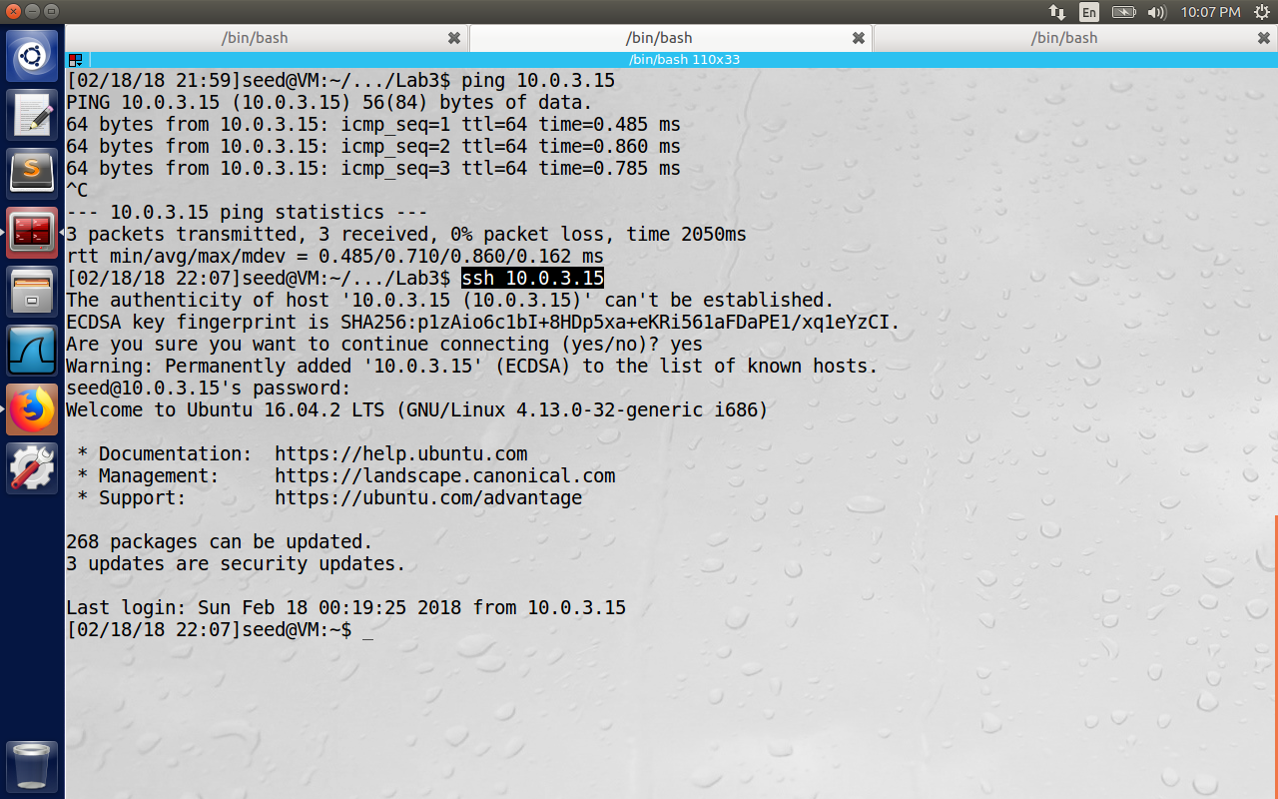

**3.2 Task 2: Set up Host-to-Gateway Tunnel**

We have used host-host tunnel. (Even though here VM1 and VM2 are in the host-only adapter network, we only simplified the setup. This connection emulates the real connection through the internet.) We are not just interested in accessing the VM2 through the host tunnel, but to use it as a means to bypass firewall placed on the client side. i.e., enable VM2 to route the packets to the destinations on the internet.

1. Set up IP forwarding

A router has multiple network interfaces. If traffic comes in on one interface that matches a subnet of another network interface, a router then forwards that traffic to the other network interface. For this we have to enable kernel IP forwarding i.e., (otherwise if the kernel receives a packet with destination that is not of the interface, it may discard the packet.). Use the command   
“sudo sysctl net.ipv4.ip_forward=1”. Then check the flag using cat /proc/sys/net/ipv4/ip_forward

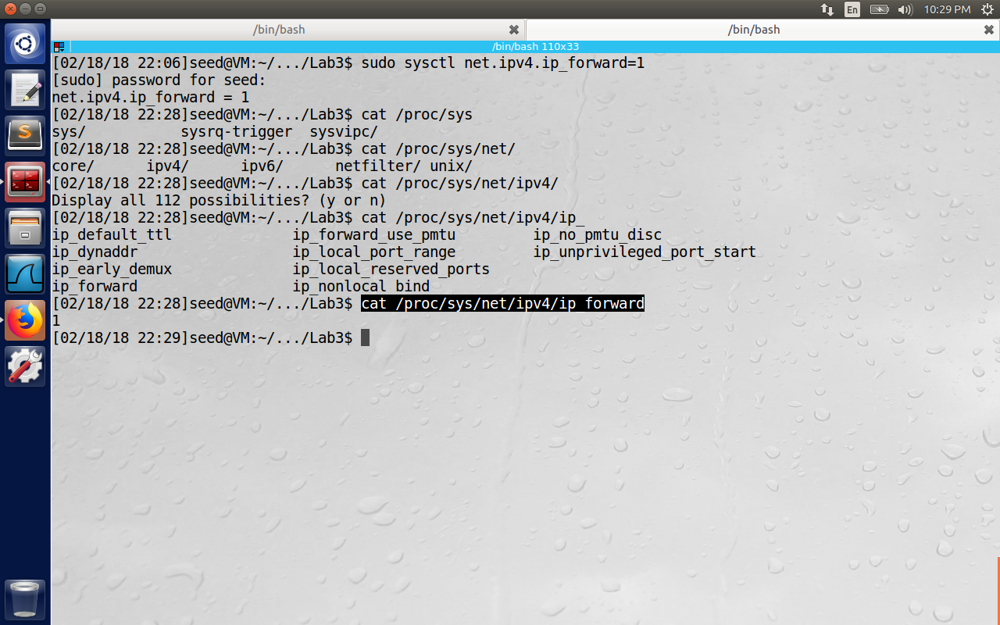

2. Get around the limitation of NAT:

When the destination sends the packets to private network, it reaches the NAT server first (because the source IP of outgoing packets are changed to NAT’s external IP (which is Host IP in our setup). NAT will replace destination with IP address of original packet (It is 10.0.3.15 in this case). But NAT needs to know the mac address of VM2 before sending such packets. But the TUN interface (10.0.3.15) is connected to private network only through tunnel, cannot receive arp request, so NAT will drop such packets. We can do arp cache poisoning on NAT with the mac address of 10.0.3.15 interface.

3. Another way to get around the limitation of NAT:

Now another way to get around the limitation is to create NAT on VM2 itself, so that packets coming out of VM2 will have source IP of VM2 itself. To reach the internet, these packets will reach another NAT, provided by virtual Box, and the second VM can easily relay the traffic to VM2. The below commands enable NAT on VM2. Here we are first clearing the IP tables and then clear the nat iptable. Finally add a rule on the post routing position to the Nat Network adapter. (which is enp0s3 in this case). Basically we are telling to use NAT adapter after the post routing of the packets, so all the packets will have source IP of VM2.

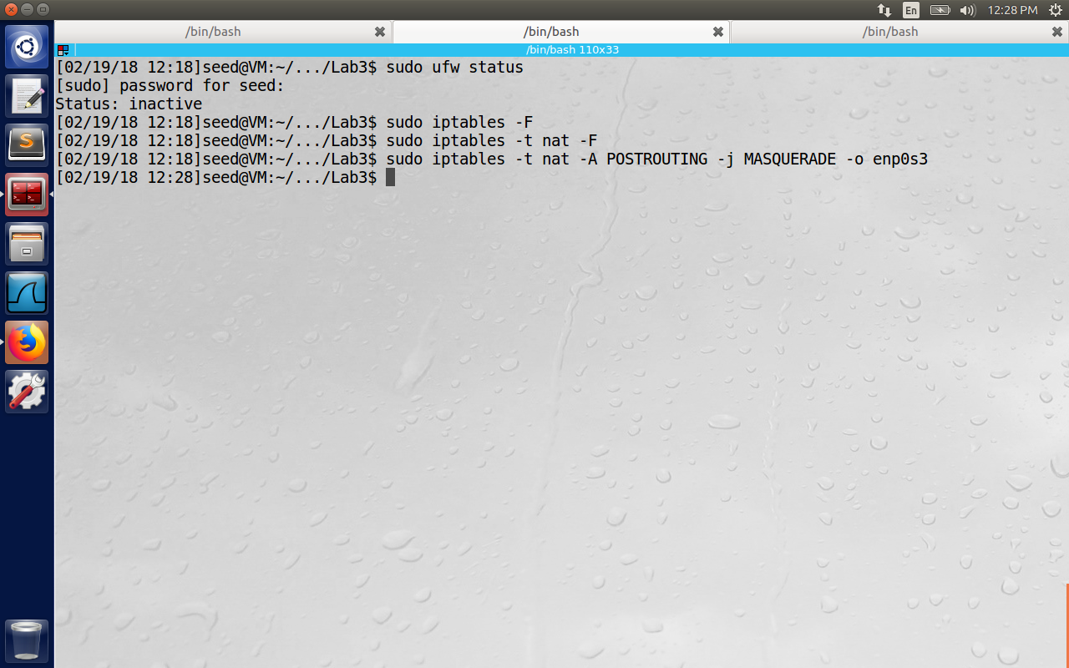

**3.3 Task 3: Set up Firewall**

Set up the firewall on VM1 to block the access of a target web site. You need to make sure that the IP address of the target web site is either fixed or in a fixed range. Here we decided to block access to Syracuse.edu because it will have fixed IP. (against websites like Facebook which can frequently change the destination IP address).

Ideally Firewall needs to run on different VM but with our limitation of VMs we are running it on the client side itself. We need to be careful in setting up firewall because it has to only block the traffic to specific website on the real Ethernet card (but not on the virtual interface so that we can use VPN to bypass it)

The below command blocks the packets to 128.130.18.198 network from going through enp0s3 which is VM1’s real interface (in our setup, it is connected to NAT-Network adapter).

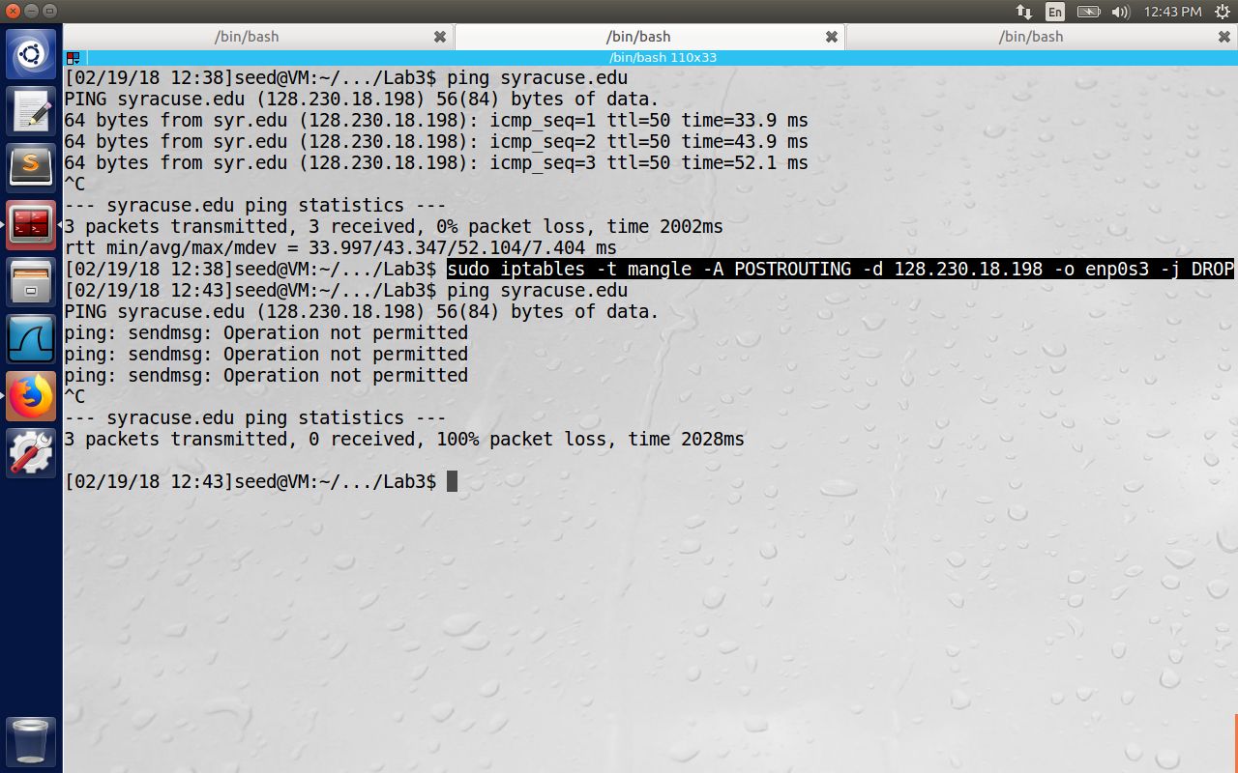

In the above screenshot, we see the packets being blocked after the firewall rule is established.

**3.4 Task 4: Bypassing Firewall**

Now we add route to send the packets to TUN interface to by-pass the firewall.

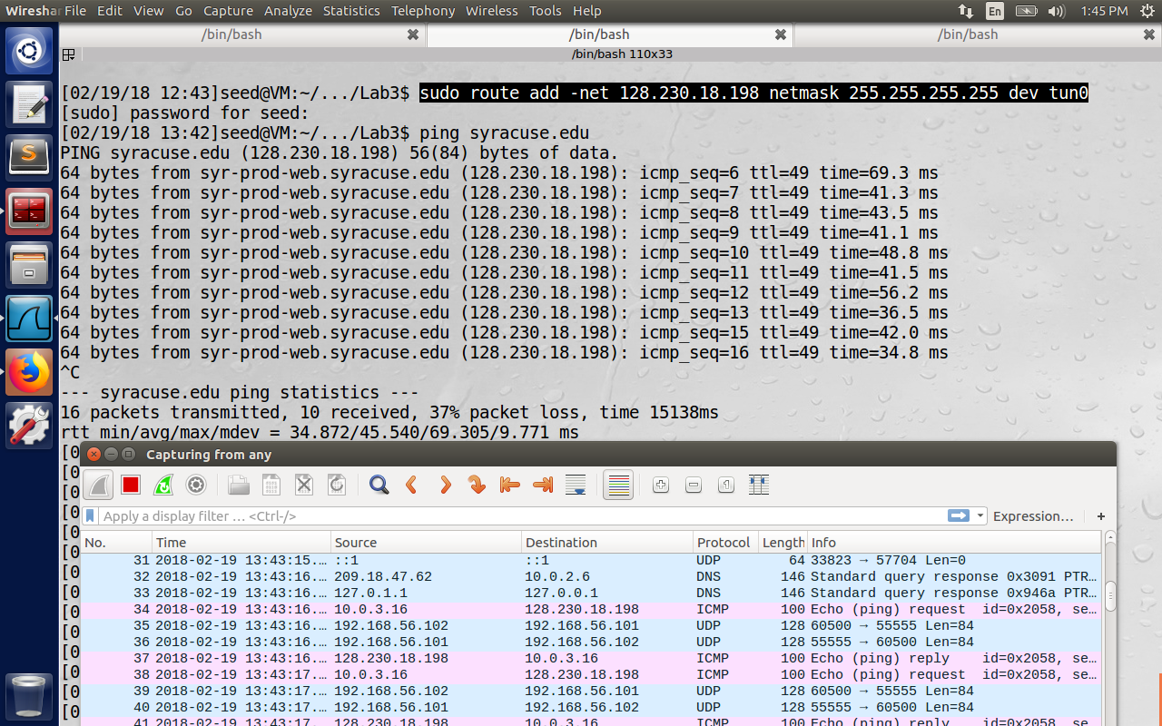

We see the ping request (ICMP) send packet to the tunnel interface(10.0.3.16), which writes the packet to the UDP socket which sends the encapsulated packet from the host-only network to VM2 IP(192.168.56.101 length = 84 bytes). The ping reply is received back on tun interface. Hence the ping works even though firewall blocked this this traffic and we have bypassed the firewall.

The same is the case even when access the Syracuse.edu through the Firefox browser.

